**English**

**Course**: 2nd year

**Date**: March, 27th

**Teacher**: Nátali Gómez

**Student**:

1. **Look and tick ( ) the symbol that represents the Internet.**



**What is the Internet?**

We can use the Internet every day. We can check e-mail, visit **websites**, play games and share photos. But can we really understand what the Internet is? Read the questions and answers to learn more.

*What is the Internet?*

The Internet is a network—a system of computer **connections**.

*Where is the Internet?*

Some people say it’s **everywhere**, but that’s not **exactly** true.

The Internet isn’t an object, so it can’t be in a place.

*How can the Internet work?*

Computers can connect to other computers with or without cables.

1. **Read and circle *T* (True) or *F* (False).**



|  |  |  |  |
| --- | --- | --- | --- |
| 1. | Every day, people can use the Internet. | T | F |
| 2. | You can visit websites on the Internet. | T | F |
| 3. | The Internet is one computer. | T | F |
| 4. | A network is a system of connections. | T | F |
| 5. | All Internet is wireless. | T | F |
| 6. | The Internet connections are an object. | T | F |
| 7. | The Internet isn’t in one place. | T | F |



**G uess What!**

An Internet connection without

cables is called a *wireless* (or *Wi-Fi*)

connection. Public places with

Wi-Fi are called *Wi-Fi hotspots*.



1. **lossary**



**websites:**

information sites on

the Internet

**connections:**

relationships

**everywhere:**

all places

**exactly:** precisely

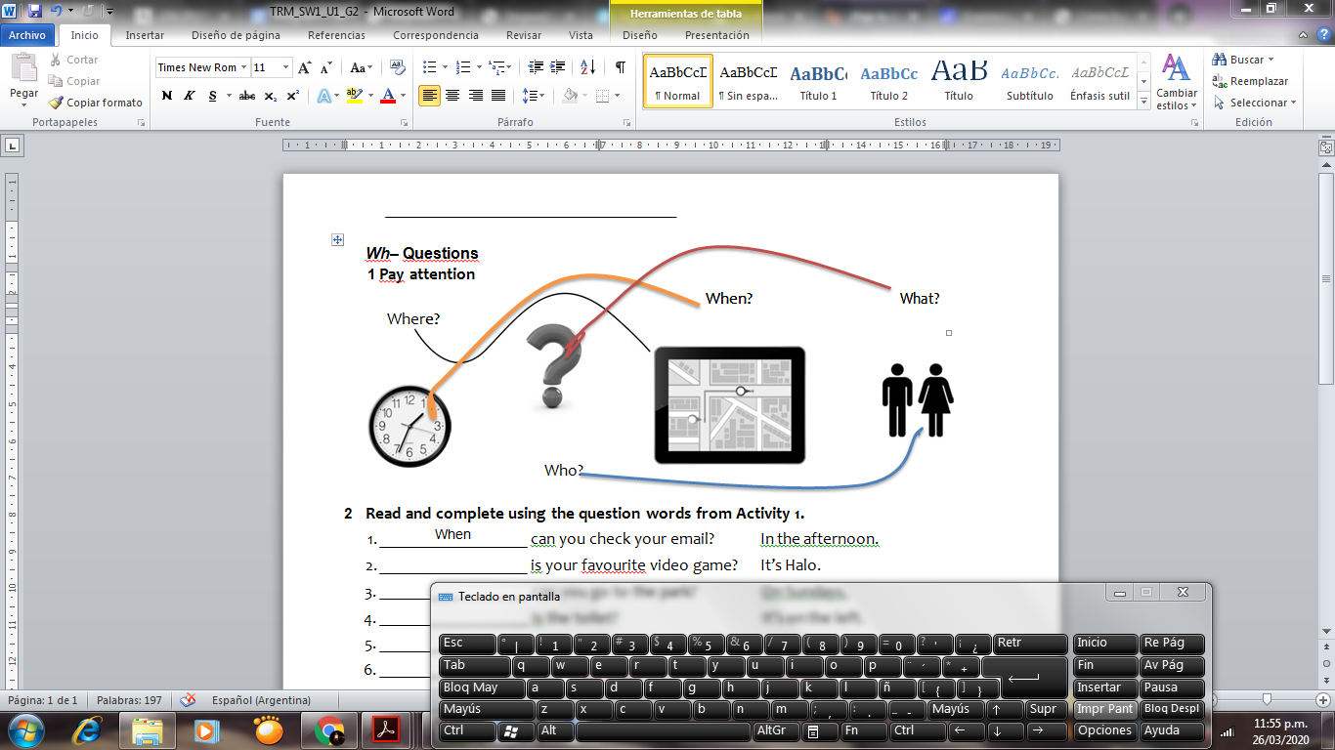

1. **Read and complete using the question words from Activity 1.**

1.

2.

3.

4.

5.

6.

When

can you check your email? In the afternoon.

is your favourite video game? It’s Halo.

can you go to the park? On Sundays.

is the toilet? It’s on the left.

can you do your homework? In the living room.

is your favourite teacher? It’s Mr Brown.

1. **Unscramble and match.**
   1. birthday / When / your / is / ?



**When is your birthday?** a. It’s on the first floor.

2. bedroom / your / is / Where / ?

b. OK.

3. these / Are / friends / your ?

c. It’s on 10th November.

4. message / this / Is / from / dad / your / ?

d. Yes, I can.

5. can / What / speak / languages / you / ?

e. No, it isn’t.

6. dance / you / Can / ?

f. Yes, they are.

7. your / Open / please / books/ , / .

g. Spanish, English and

Portuguese.

Buenas chicos, espero estén bien. Las resoluciones de estas actividades inclúyanlas acá, y espero las respuestas de lo enviado la semana pasada.

Gracias.